**Day 5 Assignment Question**

**Topic : MySQL**

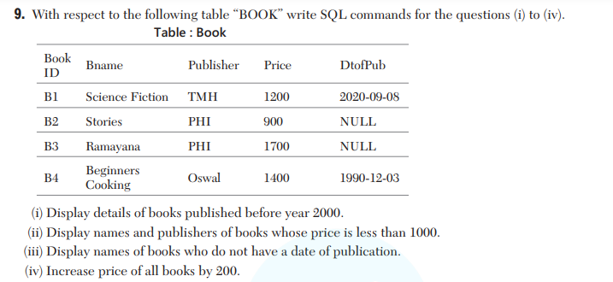

1. SELECT * FROM book WHERE DtofPub >= YEAR('2000-01-01');
2. SELECT Bname, Publisher FROM book WHERE price < 1000;
3. SELECT Bname FROM book WHERE DtofPub IS NULL;
4. SELECT price+200 FROM book;

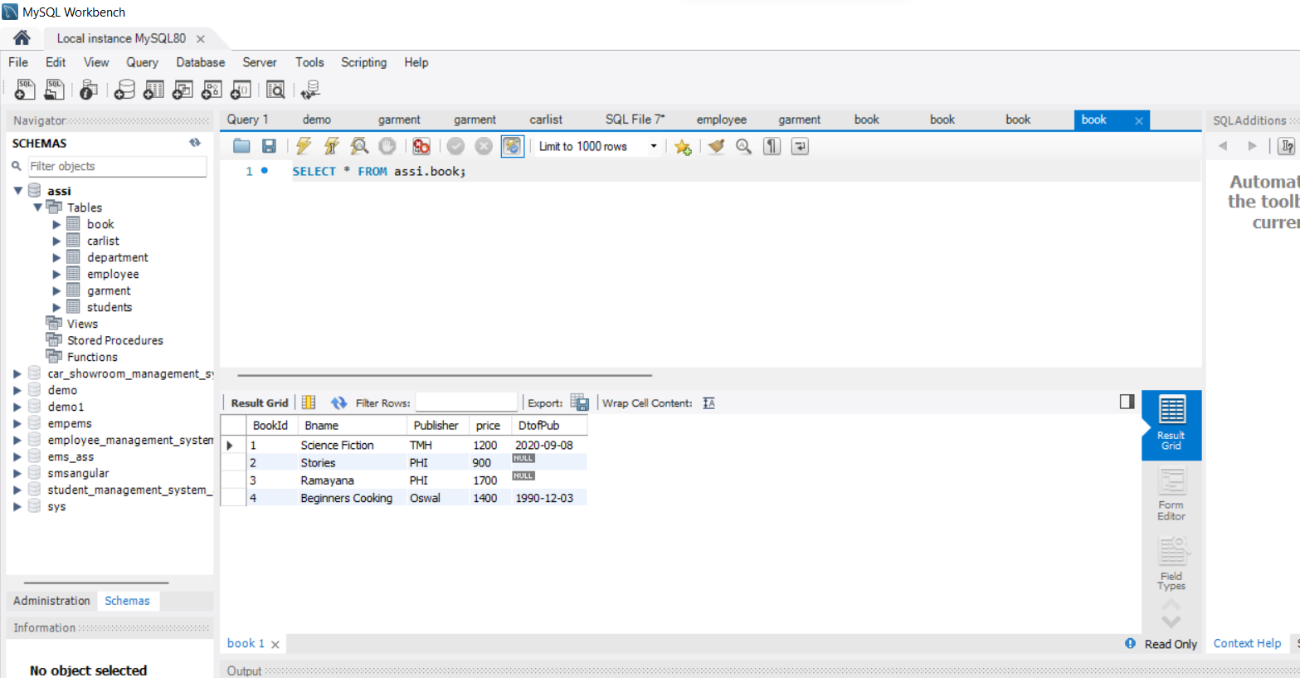

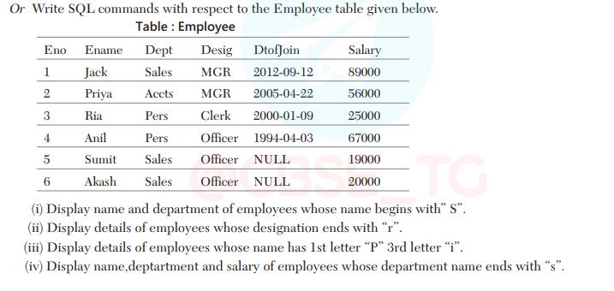

1. SELECT Ename, Dept FROM employee WHERE Ename LIKE "S%";
2. SELECT * FROM employee WHERE Desig LIKE "%r";
3. SELECT * FROM employee WHERE Ename LIKE "P_i%";
4. SELECT Ename, Dept, Salary FROM employee WHERE Dept LIKE "%s";